Nepal Earthquake 2015
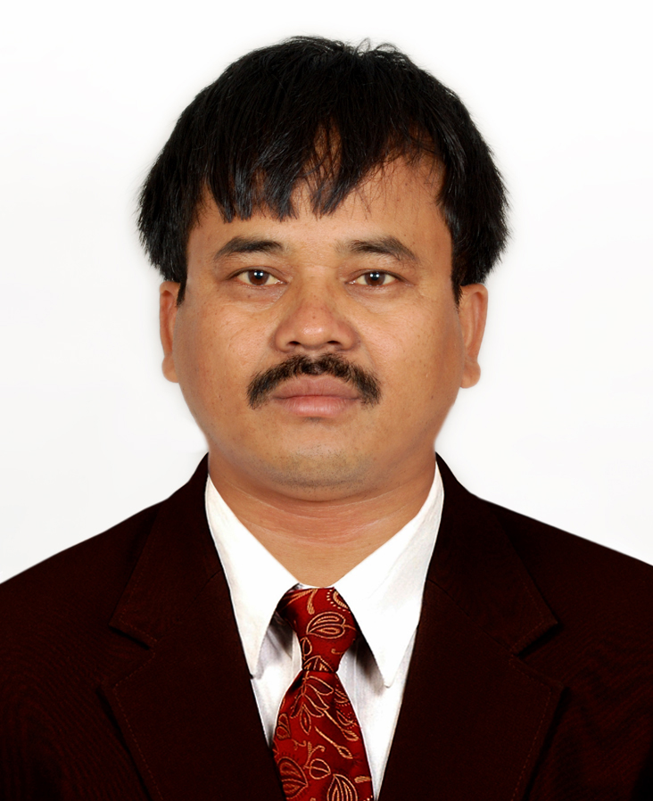
KP Rajbanshi
It was 25th April, 2015, the gloomy Saturday, yet I was with a hope to visit Kumaripati Street Festival with my two sons and taking rest at my home in Kathmandu. But, when the clock turns 11:56, the ground started shaking the house. The shaking was so strong that we could not escape out from the building and it was even hard for me to stand up on the floor. The shaking continued for about fifty seconds. When I came out of my house after shaking stopped, I saw smokes of dust blowing in the sky at some locations around my house. Telephone lines, internet connection, TV channels became out of order after a while.
Later, we knew from radio media that the shaking was of 7.8 magnitudes with its epicenter at Barpak of Gorkha district about 80 km west of Kathmandu. It hit the whole country and 14 districts of middle hilly region including capital city Kathmandu were severely affected. Aftershocks of magnitudes 4 to 7 continued shaking the mid-hilly region and it was announced by the authorities to stay outside for 72 hours. It was very socking to hear from media that many villages in Gorkha district, the location of epicenter, were completely destroyed and in Kathmandu valley many historical as well as modern buildings were collapsed. Death toll was rising abruptly. In Kathmandu almost markets were closed and people were rushing to by dry foods, water and tents for making temporary shelter on open grounds. Almost all people in Kathmandu took shelters on open grounds and streets for three days.
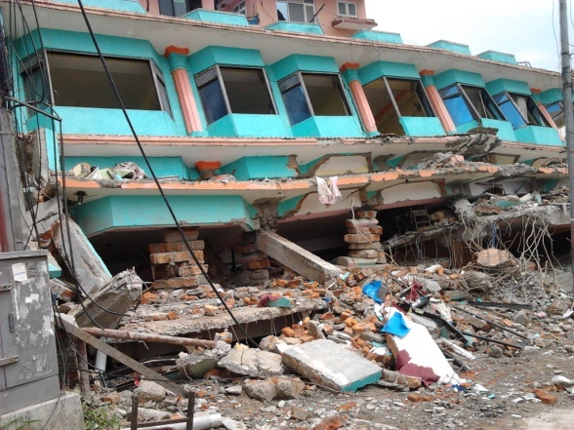 | 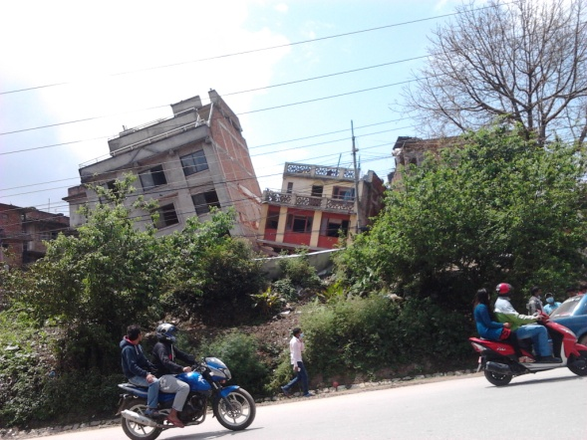

The next day on 26th April, another major shaking of 6.7 magnitude occurred at 12:54 pm which deeply terrified the people. As Kathmandu city is overcrowded and most vulnerable to earthquake disaster, 100 thousands of people moved out from Kathmandu daily. Many local organizations managed free transportation for people who wished to leave Kathmandu. More than 1 million people left Kathmandu which reduced the load of people to be managed for shelters and other daily needs. Nepal army, Nepal police, government officials engaged in rescue, relief distribution and shelter management works. Expert rescue and medical teams from many countries including Japan arrived in Kathmandu. We are very thankful to all for recuing many trapped people alive and hilling the injured people. I am personally grateful to all ICHARM team for responding about safety of ICHARM alumni in Nepal.
Tragedy over tragedy; Nepalese people were overcoming the pain of earthquake hit of 25th April. It was the 12th May 2015, daily activities were turning to as usual, all business activities had started to run smoothly, schools were announced to reopen after 2 days, at 12:51 PM another earthquake of magnitude 7.3 hit the country with its epicenter at Singati of Dolakha district, about 60 km east of Kathmandu. Hundreds of people in Dolakha districts were buried by collapsed buildings and dry landslides due to this shaking. Immediately after this shaking, a American helicopter with six American and two Nepali army personnel flew towards Dolakha for rescue of victims. But mysteriously this helicopter crashed and was found two days later. A volunteered relief distribution team of Nepalese youth, comprising some geologist for geological investigation of the region as well, was on the way back to Kathmandu and some of them trapped inside their car by the landslide occurred due to shaking. On 2nd June,2015, we faced another heartfelt tragedy that an aid helicopter crashed in Sidhupalchowk. All four people including one Dutch medical professional and pilot were dead in the crash. Subek shresha , the pilot of the helicopter had rescued many injured people from remote villages.
Damages and casualties; damages due to this earthquake are irrecoverable. About 600 thousand building including 5 thousand schools were completely damaged. Many historical and cultural monuments which were preserved as UNESCO old heritage in Patan Durbar square, Basantapur Durbar square and Bhaktapur Durbar square were completely destroyed. The only one and historical view tower Sundharara in Kathmadu was also completely destroyed.. Most buildings damaged buildings were old load bearing buildings, made of stone or bricks with mud or lime mortar. But modern RCC framed structure buildings were also damaged. According official data 8844 people died and 22300 people injured due to the earthquake disaster. We realized that casualties were very low in comparison to the damages. It was because the main earthquake on 25th April occurred at right noon of Saturday, schools were off and people in village area were at work in their farms.
Challenges and opportunities; the main challenge currently facing is the temporary settlements of homeless people before monsoon starts. Many national & international organizations, individuals and major political party cadres are involved in construction of temporary houses for homeless peoples. In Kathmandu, about fifty thousand buildings are damaged which are to be demolished as early as possible for safety of other undamaged buildings. Permanent settlements of hundreds of villages, reconstruction of damaged schools, official buildings and revival of damaged UNESCO heritage areas are big challenge for Government of Nepal. Preparatory works against probable landslides during monsoon is also a great challenge for Nepal. Fragile hills in earthquake affected area are in ruptured condition. Many villages already damaged by the quake are to be resettled in safer locations immediately to avoid further damages by landslides.
The irrecoverable tragedies and losses have provided us a platform for national unity in reconstruction of the country. The politicians and Government authorities can take this moment as turning point for the prosperous development of the country by making new plans and policies.
References
- Official website for Ministry of Home Affairs, Government of Nepal; www.moha.gov.np
- Many online news portals in Nepal.
- News from media coverage since 25th April, 2015.

